RESOLUTION NO.__________

RE: CERTIFICATE OF APPROPRIATENESS UNDER THE
PROVISIONS OF THE ACT OF THE PENNSYLVANIA
LEGISLATURE 1961, JUNE 13, P.L. 282 (53
SECTION 8004) AND BETHLEHEM ORDINANCE NO.
2013-12 AS AMENDED.

WHEREAS, it is proposed to demolish the rear garage and dispose of all resulting debris at 832 Hawthorne Road; existing concrete foundation is to remain.

NOW, THEREFORE, BE IT RESOLVED by the Council of the City of Bethlehem that a Certificate of Appropriateness is hereby granted for the proposal.

Sponsored by: (s)

(s)

ADOPTED BY COUNCIL THIS DAY OF

(s)
President of Council

ATTEST:

(s)
City Clerk

HISTORIC CONSERVATION COMMISSION

CASE #1 -- It is proposed to demolish the rear garage and dispose of all resulting debris at 832 Hawthorne Road; existing concrete foundation is to remain.
OWNER/APPLICANT: John and Terri Peters/John Peters

The Commission upon motion by Ms. Starbuck and seconded by Mr. Loush adopted the proposal that City Council issue a Certificate of Appropriateness for the proposed work as presented and described herein:
- The proposal to demolish the rear garage at 832 Hawthorne Road and dispose of all resulting debris was presented by John Peters. Mr. Peters noted that the existing concrete foundation is to remain following demolition.
- HCC approval to demolish the rear garage was based upon the fact that it is a non-contributing structure within the Elmwood Park Historic District; HCC members also noted that 40 years of neglect by the property owner ultimately resulted in the need to demolish the structure.
- The motion for the proposed demolition work was unanimously approved.

JBL: jbl
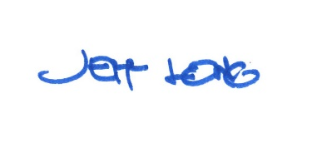

By:

Date of Meeting: June 18, 2018 Title: Historic Officer

